# Control System

## Choosing a Control System

In choosing a processing unit for the control system, the criteria most concerning the device are speed, programming difficulty and cost. The table below highlights the options available in a general sense.

|  |  |  |  |  |  |
| --- | --- | --- | --- | --- | --- |
|  | Programming  Difficulty | Speed | Power | Cost | Display |
| 8/ 16 bit microcontroller | Moderate | Fast  ~20MHz | Low  <1W | ~$50 | Difficult to add |
| 32 bit microcontroller | Moderate | Very fast  ~600MHz | Low  1-5W | ~$150-400 | Possible |
| 32 bit x86 processor (PC) | Easy/moderate | Slow/fast  (depending on OS & h/w) | High  <50W | ~$150-500 | Easy to add |
| FPGA | Moderate  -difficult | Very fast  ~100MHz (no overhead) | Low  <5W | ~$100-$800 | Difficult to add |

Table - Processing Unit Options

How fast of a processing unit do we need? We know that the system as a whole must update at a rate of at minimum 1 kHz based on the results from Nikolai’s thesis. There are two main tasks the processing unit must perform. It must first read the values from the encoders/sensors and calculate the position of the end-effecter relative to the virtual and physical surface. Then based on that position, it must calculate the position of the hard restraint mechanism. In other words, it does a forward kinematics calculation and then a reverse kinematics calculation.

(block diagram)

x_position = Length_3 - (Length_4 * sin(Theta_4));

x_position_neg = Length_3 + (Length_4 * sin(Theta_4));

delta_z = Length_4 * (1 - cos(Theta_4));

Length_2_star = (Length_2 ^2 + delta_z ^2) ^.5;

Theta_star = tan(delta_z / Length_2) ;

Theta_12_star = Theta_12 + Theta_star ;

y_position = Length_2_star * cos(Theta_1 + Theta_12_star) - Length_1 * sin(Theta_1) ;

z_position = Length_2_star * sin(Theta_1 + Theta_12_star) + Length_1 * cos(Theta_1) ;

Figure - Code excerpt from Matlab that calculates tool position

Lookup table?

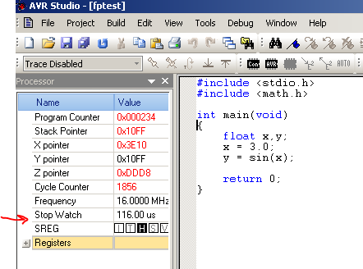

## Determining the PID Gains

## Determining the Accuracy

The accuracy of the robot is determined by the amount of error produced by the control system from the input to the output. The following diagram depicts all the possible errors involved.

encoder

Compute

position

Error 1

Compute

blocker

Error 4

Error 3

Error 2

motor

Motor controller